

CRYPTOVOTE : BLOCKCHAIN INSPIRED E-VOTING SYSTEM

PROJECT WORK REPORT PHASE II

Submitted by

DHANUSH K [22CS061]
GIRIDHARAN P [22CS074]
GOKULNATH K [22CS078]

in partial fulfillment for the award of the degree of

BACHELOR OF ENGINEERING
in
COMPUTER SCIENCE AND ENGINEERING

MUTHAYAMMAL ENGINEERING COLLEGE (AUTONOMOUS)
RASIPURAM– 637 408

ANNAUNIVERSITY: CHENNAI- 600 025

APRIL 2026

MUTHAYAMMAL ENGINEERING COLLEGE (AUTONOMOUS)
RASIPURAM BONAFIDE CERTIFICATE
Certified that this Report “ CRYPTOVOTE: BLOCKCHAIN INSPIRED E-VOTING SYSTEM ” is the conafide work of “ DHANUSH K [22CS061], GIRIDHARAN P [22CS074], GOKULNATH K [22CS078] ” who carried out the work under my supervision.

SIGNATURE SIGNATURE
Dr.G.KAVITHA, M.S (By Research), Ph.D., Mrs.K.GANDHIMATHI, M.E.,(Ph.D), PROFESSOR ASSISTANT PROFESSOR

HEAD OF THE DEPARTMENT SUPERVISOR
Department of Computer Science and Department of Computer Science and Engineering, Engineering,
Muthayammal Engineering College Muthayammal Engineering College (Autonomous), Rasipuram-637 408. (Autonomous), Rasipuram-637 408.

Submitted for the Project Work Phase-II Viva-Voce examination held on

INTERNAL EXAMINER EXTRENAL EXAMINER

ACKNOWLEDGEMENT

We would like to thank our College Chairman Shri.R.KANDASAMY and our Secretary Dr.K.GUNASEKARAN, M.E., Ph.D., F.I.E., who encourages us in all activities.
We here like to record our deep sense of gratitude to our beloved Principal Dr.P.SENTHILKUMAR, M.E., Ph.D.(IITM), for providing us the required facility to complete our project successfully.
We extend our sincere thanks and gratitude to our Head of the Department Dr.G.KAVITHA, M.S(By Research), Ph.D., Department of Computer Science and Engineering for her valuable suggestions throughout the project.
It is pleasure to acknowledge the contribution made by our Project Coordinator Mrs.M.BUVANESWARI, B.Tech., M.E., (Ph.D), Assistant Professor, Department of Computer Science and Engineering for her efforts to complete our project successfully.
It is grateful to acknowledge the support provided by our Project Guide Mrs.K.GANDHIMATHI, M.E., (Ph.D), Assistant Professor, Department of Computer Science and Engineering for her guidance to complete our project successfully.
We are very much thankful to our Parents, Friends and all Faculty Members of the Department of Computer Science and Engineering, who helped us in the successful completion of the project.

Vision of the Institute
To be a Centre of excellence in Engineering, Technology and Management on par with international standards

Mission of the Institute
- To prepare the students with high professional skills and ethical values
- To impart knowledge through best practices
- To instill spirit of innovation through training, research and development
- To undertake continuous assessment and remedial measures
- To achieve academic excellence through intellectual, emotional and social stimulation

Vision of the Department
To produce the Computer Science and Engineering graduates with the Innovative and Entrepreneur skills to face the challenges ahead

Mission of the Department
M1: To impart knowledge in the state of art technologies in Computer Science and Engineering
M2: To inculcate the analytical and logical skills in the field of Computer Science and Engineering
M3: To prepare the graduates with Ethical values to become successful Entrepreneurs

Program Educational Objectives (PEOs)
PEO1: Graduates will be able to Practice as an IT Professional in Multinational Companies
PEO2: Graduates will be able to Gain necessary skills and to pursue higher educationfor career growth
PEO3: Graduates will be able to Exhibit the leadership skills and ethical values in theday to day life

Program Outcomes (POs)
PO1 - Engineering knowledge: Apply the knowledge of mathematics, science, engineering fundamentals, and an engineering specialization to the solution of complex engineering problems.
PO2 - Problem analysis: Identify, formulate, review research literature, and analyze complex engineering problems reaching substantiated conclusions using first principles of mathematics, natural sciences, and engineering sciences.
PO3 - Design/development of solutions: Design solutions for complex engineering problems and design system components or processes that meet the specified needs with appropriate consideration for the public health and safety, and the cultural, societal, and environmental considerations.
PO4 - Conduct investigations of complex problems: Use research-based knowledge and research methods including design of experiments, analysis and interpretation of data, and synthesis of the information to provide valid conclusions.
PO5 - The engineer and society: Apply reasoning informed by the contextual knowledge to assess societal, health, safety, legal and cultural issues and the consequent responsibilities relevant to the professional engineering practice.
PO6- Environment and sustainability: Understand the impact of the professional engineering solutions in societal and environmental contexts, and demonstrate the knowledge of, and need for sustainable development.
PO7 - Ethics: Apply ethical principles and commit to professional ethics and responsibilities and norms of the engineering practice.
PO8 - Individual and team work: Function effectively as an individual, and as a member or leader in diverse teams, and in multidisciplinary settings.

PO9 - Communication: Communicate effectively on complex engineering activities with the engineering community and with society at large, such as, being able to comprehend and write effective reports and design documentation, make effective presentations, and give and receive clear instructions.
PO10 - Project management and finance: Demonstrate knowledge and understanding of the engineering and management principles and apply these to one’s own work, as a member and leader in a team, to manage projects and in multidisciplinary environments.
PO11 - Life-long learning: Recognize the need for, and have the preparation and ability to engage in independent and life-long learning in the broadest context of technological change.

Program Specific Outcomes (PSOs)
PSO1: Graduates will be able to design intelligent systems and apply algorithms to develop efficient real-world solutions.
PSO2: Graduates will demonstrate knowledge of system architecture, networking, and information security to ensure reliable and secure computing.

COURSE OUTCOMES:
At the end of the course, the student will able to
21CSP02.CO1 Design an experiment to solve engineering/societal
problems using modern tools
21CSP02.CO2 Develop lifelong learning to keep abreast of the latest
technologies
21CSP02.CO3 Implement the workflow to provide sustainable
solutions
21CSP02.CO4 Interpret the experimental results and the impact on
society and environment
21CSP02.CO5 Investigate the application for the real time problems

PO1 | PO2 | PO3 | PO4 | PO5 | PO6 | PO7 | PO8 | PO9 | PO10 | PO11 | PSO1 | PSO2
✔ | ✔ | ✔ | ✔ | ✔ | ✔ | ✔ | ✔ | ✔ | ✔ | ✔ | ✔ | ✔

SIGNATURE OF STUDENTS SIGNATURE OF GUIDE

INDEX

CHAPTER NO. | TABLE OF CONTENT | PAGE NO.
 | ABSTRACT | x
 | LIST OF FIGURES | xi
 | LIST OF ABBREVIATIONS | xii
1 | INTRODUCTION | 1
 | 1.1 PROJECT OVERVIEW | 1
 | 1.2 OBJECTIVES | 2
 | 1.3 ADVANTAGES | 2
2 | LITERATURE SURVEY | 3
 | 2.1 REVIEW 1 | 3
 | 2.2 REVIEW 2 | 4
 | 2.3 REVIEW 3 | 5
 | 2.4 REVIEW 4 | 6
 | 2.5 REVIEW 5 | 7
3 | SYSTEM ANALYSIS | 8
 | 3.1 EXISTING SYSTEM | 8
 | 3.1.1 LIMITATIONS | 8
 | 3.2 PROPOSED SYSTEM | 9
 | 3.2.1 ADVANTAGES | 9
4 | SYSTEM REQUIREMENTS | 10
 | 4.1 HARDWARE REQUIREMENTS | 10
 | 4.2 SOFTWARE REQUIREMENTS | 10
5 | PROJECT DESIGN | 14
 | 5.1 BLOCK DIAGRAM FOR CRYPTOVOTE SYSTEM | 14
 | 5.2 FRONTEND INTERACTION | 15
 | 5.3 USER AUTHENTICATION AND  VERIFICATION | 16
 | 5.4 CANDIDATE INFORMATION  MANAGEMENT | 17
 | 5.5 VOTE PROCESSING AND  VALIDATION | 18
 | 5.6 BLOCK CREATION AND SECURE STORAGE | 19
 | 5.7 RESULT GENERATION AND  ADMINISTRATION | 19
 | 5.8 USE CASE DIAGRAM | 20
6 | MODULE DESCRIPTIONS | 21
 | 6.1 SYSTEM MODULES | 21
 | 6.2 MODULE PRINCIPLES | 26
 | 6.3 FEATURES AND BENEFITS | 27
 | 6.4 COMPONENTS BREAKDOWN | 28
 | 6.5 APPLICATIONS | 29
7 | CONCLUSION AND FUTURE ENHANCEMENT | 30
 | 7.1 CONCLUSION | 30
 | 7.2 FUTURE ENHANCEMENT | 30
 | APPENDIX | 31
 | A.1 BACKEND SOURCE CODE | 31
 | A.2 FRONTEND SOURCE CODE | 43
 | A.3 SCREENSHOTS | 45
 | REFRENCES | 48
 | PUBLICATION / CONFERENCE | 49

ABSTRACT

CryptoVote is a blockchain-inspired electronic voting system designed to provide a secure, transparent, and tamper-proof election process. The system transforms each vote into a cryptographically hashed block and links it to the previous one, forming an immutable chain where any alteration becomes immediately detectable. Election data is stored in a structured and lightweight format, ensuring fast access, easy verification, and strong integrity throughout the voting lifecycle. The platform offers a clear and user-friendly voting experience, allowing individuals to authenticate, review candidates, cast votes, and verify that their submission has been securely recorded. By applying core blockchain principles such as hashing, immutability, and sequential block linking CryptoVote strengthens trust, ensures confidentiality, supports accurate auditing, and enhances overall election reliability. This approach demonstrates the practical use of blockchain concepts for secure digital governance, providing a modern and dependable framework for future e-voting systems. In addition, the system reduces reliance on traditional centralized databases prone to manipulation, offering a more resilient structure for managing digital elections. Its lightweight design makes it suitable for institutions of varying sizes, from small organizations to large-scale polls. Overall, CryptoVote represents a forward-looking solution that aligns with the growing global demand for secure and transparent electronic voting.

LIST OF FIGURES

FIGURE NO. | FIGURE NAME | PAGE NO.
5.1 | Block Diagram | 14
5.2 | Use Case Diagram | 20
A.3.1 | User Interface | 45
A.3.2 | User Authentication Interface | 45
A.3.3 | User Dashboard Interface | 46
A.3.4 | Admin Dashboard Interface | 46
A.3.5 | Live Voting Results | 47
A.3.6 | Election Results Interface | 47

LIST OF ABBREVIATIONS

TERM | ABBREVIATION
AI | Artificial Intelligence
API | Application Programming Interface
CSS | Cascading Style Sheets
HTML | Hyper Text Markup Language
JS | JavaScript
JSON | JavaScript Object Notation
SHA256 | Secure Hash Algorithm 256-bit
SQL | Structured Query Language
RAM | Random Access Memory
CPU | Central Processing Unit
SSD | Solid State Drive
RESTful API | Representational State Transfer API

CHAPTER 1
INTRODUCTION

  - PROJECT OVERVIEW
CryptoVote is a blockchain-inspired e-voting system designed to ensure transparent, tamper-proof, and verifiable elections through secure digital interactions. Traditional voting systems often face challenges such as fraud, lack of transparency, dependence on manual supervision, and delays in counting, all of which weaken public trust in the electoral process.
CryptoVote addresses this by applying blockchain principles to create an immutable and trustworthy chain of vote records, ensuring that every vote remains confidential, accurately stored, and protected from unauthorized alterations. At its core, the system links each vote as a block using the SHA256 hashing algorithm, making the stored data nearly impossible to manipulate since any change to a single block affects the entire chain. The platform uses Python and FastAPI on the backend for fast, secure processing, while HTML, CSS, and JavaScript provide an intuitive voting interface that allows users to authenticate, cast votes, and receive confirmation.
Election data is stored in structured JSON files, keeping the system lightweight while maintaining consistency, accessibility, and auditability. Overall, CryptoVote demonstrates a practical and effective implementation of blockchain principles to deliver a secure, transparent, and reliable digital voting experience. By offering a secure and user-friendly digital voting solution, CryptoVote supports the evolution of democratic participation in the digital era and forms a strong foundation for future advancements in electronic voting technologies.

OBJECTIVES

    - To develop a secure, transparent, and tamper-proof e-voting platform using blockchain principles.
    - To ensure voter confidentiality and vote integrity through cryptographic hashing and immutable record-keeping.
    - To implement a blockchain-inspired linked block structure using Python and SHA-256.
    - To create an interactive web interface for voter authentication, voting, and result verification.
    - To provide audit mechanisms that allow voters and observers to verify recorded votes.

ADVANTAGES

    - Provides a highly secure and tamper-resistant voting process through cryptographic linking.
    - Guarantees transparency as all votes are verifiable and accessible for auditing.
    - Protects voter privacy while ensuring vote confidentiality and authenticity.
    - Enhances voter confidence by offering real-time verification of vote inclusion.
    - Scalable architecture supports elections from small organizations to national levels.

CHAPTER 2
LITERATURE SURVEY
2.1 REVIEW 1
AUTHOR : A. Shaikh, B. Kumar, and R. Mehta
TITLE : Blockchain-Enhanced Electoral Integrity
PUBLISHER : IEEE (International Conference Secure Digital Governence)
VOLUME NO : 4
YEAR : 2025
This study demonstrates how blockchain technology significantly enhances electoral transparency and security by utilizing cryptographically linked blocks to form an immutable voting ledger. In such systems, each vote is recorded as a transaction within a block, and every block is connected to the previous one using a unique cryptographic hash generated through the SHA-256 algorithm. This structure ensures that once a vote is recorded, it cannot be altered or deleted without affecting the entire chain, thereby making any tampering attempts easily detectable. The decentralized nature of blockchain further strengthens the system by distributing data across multiple nodes, ensuring that no single authority has complete control over the voting records. This increases trust among users, as the system becomes transparent, verifiable, and resistant to fraud. In addition, blockchain-based voting systems provide auditability, allowing voters and administrators to verify the integrity of the election process. Each transaction is time-stamped and permanently stored, enabling accurate tracking of votes and ensuring accountability. This features promising solution for modern electronic voting systems, particularly in scenarios where trust and transparency are critical.

2.2 REVIEW 2
AUTHOR : A. Sharma, P. Verma, and S. Roy
TITLE : Blockchain-Based E-Voting
PUBLISHER : IEEE (International Conference on Smart Digital Systems)
VOLUME NO : 2
YEAR : 2022
The proposed blockchain-based e-voting model focuses on securing vote transmission by embedding each vote into an immutable digital ledger. In this system, every vote is treated as a transaction and stored within a block, which is then linked to previous blocks using cryptographic hashing techniques such as SHA-256. This ensures that once a vote is recorded, it cannot be modified or deleted without affecting the entire blockchain. As a result, any attempt to tamper with the voting data becomes immediately detectable, thereby maintaining the integrity and transparency of the election process. The system also enhances trust among users, as the voting records are permanently stored and can be verified at any time.In addition to data integrity, blockchain-based e-voting systems provide strong security features such as encryption, decentralization, and transparency. Each vote is securely transmitted and recorded, reducing the risk of fraud, duplication, or unauthorized access. Furthermore, voters can verify their votes without revealing their identity, ensuring both privacy and accountability within the system. Another drawback is the high computational and energy requirements associated with blockchain mining. Maintaining a decentralized network with multiple nodes increases infrastructure costs and complexity. Additionally, the system may face scalability issues, as the processing speed decreases when the number of users increases. These limitations can affect the overall efficiency and usability of the voting system.
2.3 REVIWE 3
AUTHOR : S.H. Shakir
TITLE : A Blockchain-Based E-Voting System for Fast and Secure
Elections
PUBLISHER : IEEE (International Conference Emerging Computing
Technologies)
VOLUME NO : 5
YEAR : 2024
This research proposes a decentralized e-voting platform designed to provide fast, secure, and transparent election processes. The system operates by encrypting each vote into a secure data packet before transmission. These encrypted vote packets are then stored on a distributed ledger, ensuring that all voting data is shared across multiple nodes in the network. This decentralized structure enhances transparency, as every node maintains a copy of the voting records, making it difficult for any single entity to manipulate or tamper with the data. The use of encryption further strengthens security by protecting voter information and ensuring that votes remain confidential throughout the process.One of the key advantages of this approach is improved data authenticity. Since each vote is validated and recorded across multiple nodes, any unauthorized modification becomes easily detectable. The distributed ledger ensures that the system is resistant to single-point failures and enhances trust among users by providing a transparent and verifiable voting environment. Additionally, voters can verify that their votes have been recorded correctly without compromising their identity, which is an important requirement in modern digital voting systems. .Another limitation is the increased infrastructure requirement needed to maintain multiple nodes. Setting up and managing a distributed network can be costly and technically complex.

2.4 REVIEW 4
AUTHOR : U. Jafar and K. Hussain
TITLE : Blockchain for Electronic Voting Systems
PUBLISHER : IEEE (International Conference on Advanced Cyber
Technologies)
VOLUME NO : 1
YEAR : 2021
This review highlights several critical challenges associated with blockchain-based voting systems, focusing on issues such as storage overhead, privacy concerns, complex system architectures, and high computational costs. In many existing models, every vote is stored permanently on the blockchain, leading to a continuous increase in data size. Over time, this creates significant storage overhead, making it difficult to manage and maintain the system efficiently. Additionally, as the number of voters increases, the blockchain grows larger, resulting in slower data retrieval and reduced system performance.Another major concern identified in the review is voter privacy. While blockchain systems are transparent by nature, ensuring complete anonymity of voters while maintaining verifiability is a complex task. Some systems risk exposing sensitive information if not properly designed, which can compromise voter confidentiality. Balancing transparency with privacy remains one of the biggest challenges in blockchain-based e-voting systems.The review also points out the complexity of system design in many blockchain implementations. Most models rely on advanced mechanisms such as consensus algorithms, distributed networks, and cryptographic protocols, which make the system difficult to implement and maintain. These systems often require specialized infrastructure and technical expertise, limiting their practical adoption in real-world scenarios. Furthermore, high computational costs associated with mining and transaction validation increase energy consumption and reduce efficiency.
2.5 REVIEW 5
AUTHOR : R. P. Tejushree, V. Nair, and S. Kumar
TITLE : Secure E-Voting: Leveraging Blockchain Technology
PUBLISHER : IEEE (International Conference on Distributed Digital
Security)
VOLUME NO : 3
YEAR : 2024
Tejushree’s study highlights the importance of cryptographic techniques in developing secure and reliable online voting systems. The proposed model focuses on protecting the integrity and confidentiality of votes by using encryption methods during vote transmission. In this system, each vote is securely encrypted before being sent over the network, ensuring that unauthorized users cannot access or modify the voting data. Additionally, the system uses decentralized data storage, where voting records are distributed across multiple nodes. This reduces the risk of manipulation, as no single entity has full control over the data. These features make the system highly secure and resistant to fraud or tampering.Another key advantage of this approach is its ability to maintain data integrity. Once a vote is recorded, it becomes part of a secure ledger, making it difficult to alter without detection. The use of cryptographic algorithms ensures that any change in the data will result in a mismatch, thereby preserving the authenticity of the voting process. This builds trust among users and ensures that election results are accurate and verifiable.However, despite its strong security features, the system faces several practical challenges. One of the major limitations is the complexity of the user interface. Since the system is based on blockchain technology, it often requires users to understand concepts such as encryption, digital signatures, and secure keys. This can be difficult for voters who are not familiar with technical systems, leading to usability issues and reduced adoption.

CHAPTER 3 SYSTEM ANALYSIS
  - EXISTING SYSTEM

- Traditional electronic voting systems depend on centralized databases, making them vulnerable to tampering, fraud, and errors, while paper-based voting remains slow, difficult to audit, and less accessible.
- Many digital voting platforms offer convenience but lack transparency, are exposed to cyber-attacks, and often fail to consistently protect voter anonymity, reducing public trust.
- Blockchain-based voting solutions show promise but face issues such as scalability, latency, and low user adoption; without strong cryptographic verification and decentralization, these systems still remain susceptible to fraud.
    - LIMITATIONS
      - Blockchain technology may introduce latency and scalability challenges under high transaction loads in large elections.
      - Complex voter authentication remains a concern for ensuring only eligible voters participate without compromising anonymity.
      - User adoption can be hindered due to general distrust or lack of familiarity with blockchain and digital voting systems.
      - Infrastructure requirements and internet access limitations can exclude some voter populations.
      - The system requires rigorous security audits to prevent potential cyber-attacks or vulnerabilities.

  - PROPOSED SYSTEM

- CryptoVote proposes a blockchain-inspired e-voting system using Python and FastAPI for backend processing integrated with cryptographic SHA256 hashing to create immutable vote blocks stored in efficient JSON files. This system guarantees vote integrity by linking each vote block cryptographically to the previous one, preventing modifications.
- The frontend built with HTML, CSS, and JavaScript offers user-friendly interfaces for casting, verifying, and auditing votes. Benefits include secure, end-to-end verifiability, confidentiality of voter identities, and resistance to fraud or tampering.
- The decentralized data structure enhances transparency, while JSON file storage optimizes access speeds. CryptoVote is scalable, flexible, and practical for real elections, improving trust and participation.
    - ADVANTAGES
      - Provides enhanced security by leveraging cryptographic hashing and decentralized blockchains, making votes immutable and tamper-proof.
      - Increases transparency as all votes can be independently verified and audited on a public or distributed ledger.
      - Ensures voter privacy with encryption techniques that protect voter identity while maintaining vote integrity.
      - Speeds up the vote counting and result announcement process through instant blockchain validation.
      - Automates vote management, reducing human error and administrative overhead.

CHAPTER 4 SYSTEM REQUIREMENTS

HARDWARE REQUIREMENTS
- Processor : Intel Core i5 / i7 or equivalent
- RAM : 8 GB or higher
- Storage : 500 GB SSD
- Network : Stable internet connection

SOFTWARE REQUIREMENTS
- Programming Language : Python 3.x
- Backend Frameworks : Flask / FastAPI
- NLP & ML Libraries : ChatterBot, spaCy, NLTK, Pandas, NumPy
- Cryptographic Library : SHA-256 hashing module
- Data Format : JSON for data handling and storage
- Frontend Technologies : HTML, CSS, JavaScript
- Database : SQLite or MySQL
- Model Training Platform : Google Colab
- Web Server : Gunicorn

Python 3.x

Python 3.x is one of the most widely used programming languages due to its simple syntax, readability, and strong ecosystem. It supports file handling, networking, encryption, data processing, multi-threading, and includes an extensive standard library along with thousands of external packages through PyPI. Python enables rapid prototyping and production-ready development across domains such as automation, AI, data analytics, cybersecurity, and web services.Its seamless integration with REST APIs, cloud platforms, microservices, and machine learning frameworks enhances versatility. As an interpreted language, it supports fast testing and debugging, while regular updates provide better performance, security, async features, and type annotations—making it suitable for students, researchers, and enterprises.

Flask / FastAPI

Flask and FastAPI are popular Python frameworks used to build backend applications and APIs. Flask is a simple micro-framework that provides the basic tools needed for routing, handling requests, and rendering pages. It is easy to learn, flexible, and suitable for small to medium projects where developers want full control over the structure.
FastAPI is a newer, faster framework designed for high-performance applications. It supports asynchronous programming, automatic data validation, and generates documentation automatically. Because of its speed and efficiency, it is ideal for real-time systems, modern APIs, and scalable applications.Both frameworks integrate easily with databases, frontend technologies, and security modules. Their lightweight design and strong community support make them suitable for building reliable and maintainable backend services like CryptoVote.

SHA-256 Library

SHA-256 is a widely trusted hashing algorithm used in cybersecurity, digital signatures, SSL certificates, and blockchain systems. It generates a fixed, unique hash for any input while ensuring that even minor data changes produce entirely different outputs. Its collision resistance and integrity protection make it ideal for secure data verification. SHA-256 is lightweight, fast, and widely supported across cloud platforms, servers, mobile systems, and blockchain-inspired applications like CryptoVote, where tamper resistance is essential.

JSON Data Handling

JSON is a lightweight data format widely used in modern software systems due to its simple key–value structure, readability, and compatibility with web and mobile applications. It supports fast data exchange between servers and clients and is widely used in REST APIs, IoT systems, configuration files, and NoSQL databases like MongoDB. JSON integrates well with both Python and JavaScript, making it suitable for handling structured election data, vote records, and configuration files in systems like CryptoVote.

HTML, CSS, and JavaScript

HTML provides the structure of a webpage, defining elements such as text, forms, buttons, and layout sections. CSS handles styling, including colors, spacing, fonts, and responsive design across screen sizes. JavaScript adds interactivity, enabling dynamic content updates, client-side validation, event handling, animations, and communication with backend servers. Together, they form the core of frontend development and are essential for building responsive, user-friendly interfaces for e-voting systems and dashboards.

SQLite or MySQL

SQLite is a lightweight, file-based relational database suitable for smaller applications, offline systems, and environments with low resource usage. It requires no separate server and ensures fast and reliable data storage. MySQL is a scalable, server-based RDBMS capable of handling large datasets and multiple users simultaneously. It supports advanced features such as indexing, transactions, stored procedures, and replication. Both use SQL for consistent data management and are suitable for storing voter records, admin data, and audit logs.

Google Colab

Google Colab is a cloud-based platform that allows users to run Python code directly in the browser without local installation. It provides free GPU/TPU access, making it useful for machine learning experiments, data processing, and prototyping. Colab includes pre-installed scientific libraries, supports real-time collaboration, and integrates with Google Drive. Its notebook interface helps beginners, students, and researchers work on Python projects from any device.
Gunicorn Web Server
Gunicorn (Green Unicorn) is a production-ready Python web server used for deploying Flask and FastAPI applications. It uses a pre-fork worker model to handle multiple requests efficiently, ensuring stability and scalability during heavy traffic. Gunicorn is often paired with Nginx for load balancing, SSL management, and static file handling. Its compatibility with various deployment environments makes it a reliable choice for deploying secure, high-performance applications.

CHAPTER 5
PROJECT DESIGN
5.1 BLOCK DIAGRAM FOR CRYPTOVOTE SYSTEM
The block diagram of the CryptoVote system shows the interaction between users, the interface, and backend components managing the voting process. Voters access the frontend to log in and submit verification details. The system authenticates credentials, verifies eligibility, and displays the candidate list. After selecting a candidate, the vote is processed and sent to the blockchain engine, where it is stored securely in the JSON ledger. Administrators manage candidates and view results computed from blockchain entries. All communication occurs through structured backend processes, ensuring login to vote recording is secure, transparent, and orderly.

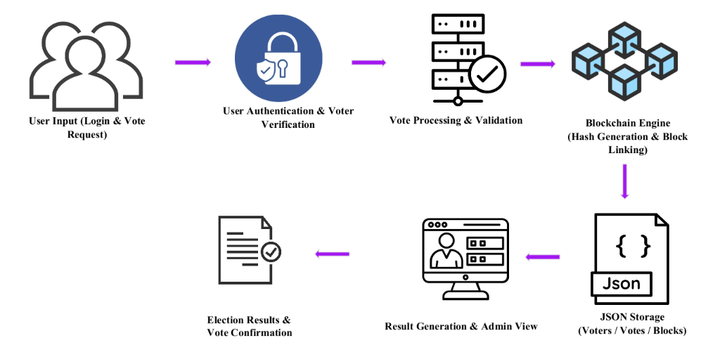

FIGURE NO. 5.1 Block Diagram

5.2 FRONTEND INTERACTION
The Frontend Interaction component represents the complete user-facing layer of the CryptoVote system. It serves as the primary interface through which both voters and administrators interact with the application. This component is designed to be simple, responsive, and user-friendly, ensuring that users can easily navigate the system without requiring technical knowledge.The frontend is developed using standard web technologies such as HTML, CSS, and JavaScript. HTML is used to structure the content of the webpages, CSS is applied to enhance the visual appearance and layout, and JavaScript enables dynamic behavior and interaction. Together, these technologies create an intuitive interface that allows users to perform all election-related activities efficiently.Through this interface, users can log in to the system, complete the necessary verification process, view the list of candidates, and cast their votes securely. Administrators can also access dedicated dashboard pages to manage candidates, monitor voting activity, and view election results. The design ensures that all functionalities are clearly organized and accessible, reducing user confusion and improving overall usability.All data entered by users on the frontend, including login credentials, voter details, and voting selections, is transmitted securely to the backend server using RESTful API calls. The frontend acts only as a communication layer and does not perform any critical processing or validation independently. Instead, all validation, authentication, and vote processing are handled by the backend to ensure security, accuracy, and data integrity.
The frontend is responsible for collecting user input, sending requests to the backend, and displaying the responses received from the server. This separation of responsibilities enhances system security and simplifies maintenance. Additionally, the responsive design ensures compatibility across different devices such as desktops, laptops, and mobile devices, making the system accessible to a wide range of users.

5.3 USER AUTHENTICATION AND VERIFICATION

The User Authentication and Verification component is a critical part of the CryptoVote system, responsible for ensuring that only authorized and eligible users can participate in the voting process. This component combines two essential functions: validating user login credentials and verifying voter eligibility. By integrating these functions, the system maintains a high level of security and prevents unauthorized access.When a user attempts to log in, their credentials are checked against the stored data maintained in JSON format.

The system identifies whether the user is a voter or an administrator based on the provided credentials. This initial authentication step acts as the first layer of security, ensuring that only registered users can access the system.After successful login, the system proceeds to the verification stage. In this stage, the voter is required to submit additional details through a verification form. The system carefully evaluates these details to confirm the voter’s identity and eligibility. It checks whether the voter is registered in the system and ensures that the same voter has not already completed the verification process. This step is essential to prevent duplicate voting and maintain fairness in the election.The use of JSON-based data storage allows the system to efficiently manage and retrieve user information while maintaining consistency.

All verification records are securely handled to avoid tampering or unauthorized modifications. By tracking verification status, the system ensures that each voter is allowed to proceed only once through the voting process. This integrated approach enhances system security by protecting against unauthorized access and repeated verification attempts. It also ensures that only legitimate and eligible users are permitted to cast their votes.

5.4 CANDIDATE INFORMATION MANAGEMENT

The Candidate Information Management component is responsible for handling all operations related to the retrieval and presentation of candidate details within the CryptoVote system. This module ensures that voters are provided with accurate, consistent, and secure information about candidates before they proceed to cast their votes. It plays a vital role in maintaining transparency and reliability throughout the election process.Once a voter successfully completes the authentication and verification process, the system grants access to the list of candidates. The candidate data is stored securely in the backend using JSON format, which allows for efficient storage, easy retrieval, and structured data handling. When requested, the backend fetches this information and prepares it for delivery to the frontend interface.
The retrieved data is then processed and organized into a structured format suitable for display. It is transmitted to the frontend through secure API calls, where it is presented to the voter in a clear and user-friendly manner. This enables voters to carefully review candidate details, such as names, identifiers, or other relevant information, before making their selection. By managing candidate data exclusively within the backend, the system ensures that the information remains protected from unauthorized modifications. This centralized control prevents any manipulation or inconsistency in candidate details, thereby preserving the integrity of the election. Only authorized administrative functions are allowed to update or manage candidate records, ensuring controlled access and accountability.
Additionally, this component enhances system transparency by providing all voters with the same consistent and verified set of candidate information. It eliminates discrepancies and ensures fairness, as every voter makes decisions based on identical data.

5.5 VOTE PROCESSING AND VALIDATION

The Vote Processing and Validation component is responsible for managing and verifying every vote submitted within the CryptoVote system. It ensures that each vote is authentic, valid, and eligible before being recorded in the system. This module plays a crucial role in maintaining the integrity, fairness, and reliability of the entire voting process. When a verified voter selects a candidate and submits their vote, the system first performs a series of validation checks. It confirms whether the voter is eligible to cast a vote and verifies that the voter has not already participated in the election. This step is essential to prevent duplicate voting and ensure that each voter is allowed to vote only once.

Once the eligibility checks are successfully completed, the system prepares the vote data for further processing. This includes collecting essential details such as the candidate ID, voter reference (in a secured or hashed format), and the timestamp of the vote. These details are structured in a standardized format to ensure consistency and ease of processing in subsequent stages. The component also verifies that the vote request originates from an active and authenticated session. This prevents unauthorized users or external entities from submitting invalid or malicious requests. Additionally, the system ensures that the data being transmitted has not been altered during communication between the frontend and backend, thereby safeguarding against data tampering.

After successful validation, the vote is forwarded to the secure recording mechanism, where it is stored as part of the blockchain-inspired structure. By allowing only validated and authenticated votes to proceed, this module guarantees that the voting data remains accurate and trustworthy.

5.6 BLOCK CREATION AND SECURE STORAGE

Block Creation and Secure Storage combines the blockchain functions with the JSON ledger system to securely record every validated vote. Once a vote is approved, the system generates a block containing essential details such as the candidate ID, timestamp, and a reference to the voter. This block is then processed using the SHA-256 hashing algorithm, creating a unique hash that ensures the block cannot be altered without detection.
The new block is linked to the previous one, forming a continuously growing and immutable chain of vote records. All generated blocks are stored in the blockchain.json file, alongside additional JSON files that hold voter and candidate information for reference. This integrated structure keeps the entire voting history tamper-proof, fully traceable, and permanently preserved in an organized and verifiable format. By maintaining strong data integrity and transparency, this component ensures long-term security and trust in the election system.

5.7 RESULT GENERATION AND ADMINISTRATION

Result Generation and Administration handles the computation of election outcomes and provides administrators with tools to monitor system activity. The system reads all stored blocks, extracts candidate IDs, and calculates the total votes for each candidate, ensuring that results are computed directly from the immutable blockchain data. Administrators can view these results through a dedicated interface that also allows them to inspect blockchain entries if needed. This component ensures transparent result calculation and supports effective election oversight.

5.8 USE CASE DIAGRAM

The e-voting system ensures secure, transparent election management by verifying user login details, validating voter information, and allowing only eligible users to continue. Verified voters can view the official candidate list and cast their vote, which is securely stored as an immutable blockchain block. Users can verify their recorded vote, and the system generates accurate results directly from the blockchain. Administrators can update candidate details and audit blockchain records to confirm data integrity throughout the election process.
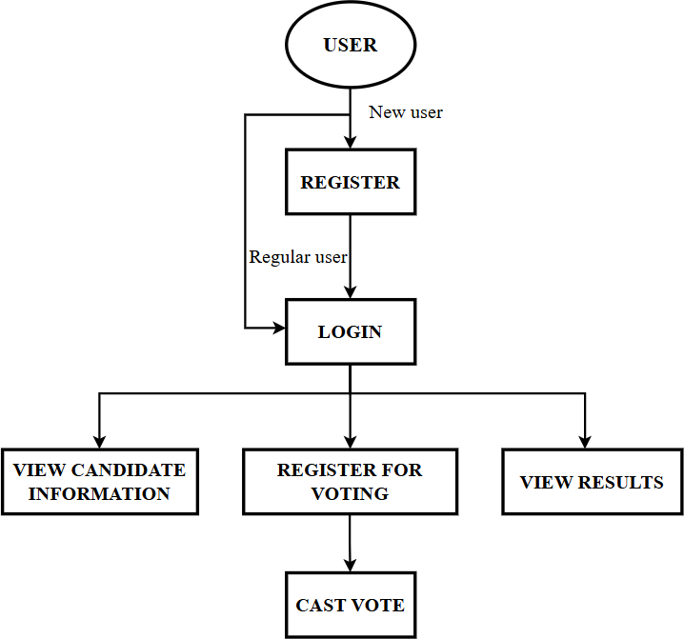

FIGURE NO. 5.2 Use Case Diagram

CHAPTER 6

MODULE DESCRIPTIONS

6.1 SYSTEM MODULES

The CryptoVote system is designed using a modular architecture to ensure security, scalability, transparency, and efficiency in the electronic voting process. Each module is responsible for a specific function and interacts seamlessly with other modules to maintain the integrity of the system. This structured approach improves maintainability, enhances system performance, and ensures a clear separation of responsibilities.

1. User Authentication Module
The User Authentication Module is responsible for controlling access to the system. It validates user credentials such as username and password before granting access. This module ensures that only legitimate users can enter the system.To enhance security, passwords are stored using encryption techniques and compared during login using secure methods. It may also support session handling mechanisms such as token-based authentication or cookies to maintain login sessions securely.
Key Features:
- Secure login system with credential validation
- Password encryption and secure comparison
- Session management to prevent unauthorized reuse
- Protection against unauthorized access
This module acts as the gateway to the system, ensuring that malicious users cannot gain access to sensitive voting operations.

2. Voter Verification Module
The Voter Verification Module ensures that only eligible voters are allowed to cast their votes. It verifies voter identity using unique identifiers such as voter ID and personal details.The module maintains a record of voters who have already participated in the election. Once a voter casts a vote, their status is updated to prevent duplicate voting.
Key Features:
- Verification of voter identity
- Prevention of multiple voting attempts
- Maintenance of voter participation records
- Validation against stored voter database
This module ensures fairness and accuracy in the election by enforcing the rule of “one person, one vote.”

3. Candidate Management Module
The Candidate Management Module is designed for administrative use. It allows administrators to manage candidate-related data efficiently throughout the election process. Candidate information such as name, ID, party affiliation, and symbol is stored and managed using JSON-based storage.
Key Features:
- Add new candidates to the system
- Update candidate details when required
- Delete or remove candidates
- Display candidate list dynamically to voters

This module ensures that voters have access to correct and updated candidate information, which is crucial for making informed voting decisions.

4. Voting Module
The Voting Module provides the interface through which voters cast their votes. It ensures that the voting process is simple, secure, and user-friendly.Only authenticated and verified users can access this module. Once a vote is submitted, it is securely processed and cannot be modified or deleted.
Key Features:
- Secure vote casting interface
- One vote per voter enforcement
- Confidential handling of vote data
- Immediate forwarding of vote data to blockchain module
This module is central to the system as it directly handles the core activity of voting, ensuring both usability and security.

5. Blockchain Module

The Blockchain Module is the core component of the CryptoVote system, responsible for ensuring secure, transparent, and tamper-proof storage of all voting data. It leverages blockchain principles to maintain the integrity and authenticity of each vote cast within the system. In this module, every vote is transformed into a block and appended to a continuously growing blockchain. The system uses the SHA-256 hashing algorithm to generate a unique hash value for each block. This hash acts as a digital fingerprint, ensuring that even the smallest modification in the data will produce a completely different hash, thereby exposing any tampering attempts.

Each block contains the following components:
- Hashed Voter ID: Ensures voter anonymity while maintaining uniqueness
- Candidate ID: Identifies the selected candidate
- Timestamp: Records the exact time of vote submission
- Previous Block Hash: Links the current block to the previous block
- Current Block Hash: Represents the unique identity of the block
Key Features:
- Strong cryptographic security using hashing
- Immutable and append-only data structure
- High transparency with verifiable records
- Resistance to tampering, fraud, and unauthorized access
- Decentralization potential for future scalability
The Blockchain Module guarantees data integrity, trust, and reliability within the CryptoVote system. By eliminating the possibility of vote manipulation, it strengthens confidence in the election process and ensures that results are authentic and verifiable.

6. Data Storage Module
The Data Storage Module is responsible for efficiently managing and storing all system-related data in a structured format. It uses JSON (JavaScript Object Notation) files as the primary storage mechanism, which provides a lightweight and flexible solution for handling data. This module plays a crucial role in maintaining the consistency and accessibility of information across the system. It ensures that all data generated during the voting process is properly stored and can be retrieved whenever required.

The module stores the following data:
- Voter Data: Includes voter ID, verification status, and participation records
- Candidate Information: Details such as candidate ID, name, and associated attributes
- Blockchain Records: Complete chain of blocks containing voting data
Key Features:
- Lightweight and human-readable JSON-based storage
- Efficient data retrieval and update mechanisms
- Organized and structured data management
- Reduced dependency on complex database systems
- Suitable for small to medium-scale applications
This module ensures efficient data handling, reliability, and system performance. By using JSON storage, the system remains simple, cost-effective, and easy to maintain while still supporting transparency and accessibility.

7. Result & Verification Module
The Result & Verification Module is responsible for processing stored voting data and generating accurate election results. It interacts directly with the blockchain to retrieve vote records and compute the total votes received by each candidate.This module ensures that the result generation process is secure, transparent, and free from manipulation. Since the data is retrieved from an immutable blockchain, the results produced are highly reliable and trustworthy. In addition to result computation, this module also provides verification mechanisms that allow both voters and administrators to confirm the authenticity of votes. This enhances transparency and builds confidence in the system.
Functional Responsibilities:
- Extracting vote data from blockchain records
- Counting votes for each candidate accurately
- Generating final election results
- Displaying results in a user-friendly format
- Enabling verification of individual votes
Key Features:
- Accurate and reliable vote counting mechanism
- Transparent result generation process
- Verification of vote integrity and authenticity
- User and admin-level verification access
- Prevention of result manipulation

This module plays a vital role in establishing trust, transparency, and accountability in the election system. By ensuring that results are accurate and verifiable, it reinforces the credibility of the CryptoVote platform.

6.2 MODULE PRINCIPLES
- Security-Oriented Design: Implements cryptographic hashing (SHA256) to protect vote integrity.
- Immutability: Once a vote is recorded, it cannot be modified or deleted.
- Decentralization-Inspired Structure: Eliminates reliance on a single point of failure by using a linked block structure.
- Data Integrity: Ensures that any change in data is easily detectable.
- Automation: Automates vote casting, validation, and result generation.
- User-Friendly Interface: Provides simple interaction for voters and administrators.
- Scalability: Supports elections of different sizes and complexities.

6.3 FEATURES AND BENEFITS

Features include,
- Secure user authentication system
- Blockchain-inspired vote storage
- SHA256 cryptographic hashing
- Real-time vote verification
- JSON-based lightweight data storage
- Web-based user interface
- Admin panel for candidate management
- Transparent result generation
- User-friendly voting interface for easy interaction
- Secure vote confirmation and notification system
- Immutable block structure for tamper-proof records

Benefits include,
- Enhances election security and prevents tampering
- Maintains voter privacy and confidentiality
- Reduces human error in vote counting
- Improves transparency and trust in elections
- Enables faster result processing
- Supports remote and digital voting
- Reduces operational and administrative costs
- Scalable for institutional and organizational use
- Provides real-time vote verification for users
- Ensures data integrity using cryptographic hashing
- Eliminates dependency on paper-based voting systems
- Offers easy integration with future digital governance platforms

6.4 COMPONENTS BREAKDOWN
The system is composed of the following major components:

1. Input Component
- User credentials (login details)
- Voter information
- Candidate data

2. Processing Component
- Authentication and verification
- Vote validation
- Block creation using SHA256
- Hash linking and chain formation

3. Blockchain Component
- Block structure generation
- Hash calculation
- Linking with previous blocks
- Maintaining immutable ledger

4. Storage Component
- JSON file storage for blockchain data
- Candidate and voter records
- Efficient data retrieval

5. Output Component
- Vote confirmation messages
- Blockchain verification details
- Election results display

6.5 APPLICATIONS
The CryptoVote system can be effectively applied across multiple domains that require secure, transparent, and reliable voting mechanisms. By leveraging modern technologies such as blockchain and cryptographic hashing, the system ensures data integrity, voter privacy, and tamper-proof record management. Its flexibility and scalability make it suitable for a wide range of real-world applications:
- Government Elections: National, state, and local elections with secure digital infrastructure
- Educational Institutions: Student elections and university voting systems
- Corporate Sector: Board member decisions and shareholder voting
- Online Polling Systems: Surveys, opinion polls, and public feedback platforms
- Secure Decision-Making Platforms: Organizations requiring transparent and auditable voting
- E-Governance Systems: Digital governance applications requiring trust and accountability

CHAPTER 7
CONCLUSION AND FUTURE ENHANCEMENT

  - CONCLUSION
CryptoVote effectively harnesses blockchain principles to create a secure, transparent, and tamper-proof e-voting system that is suitable for a wide range of electoral contexts. By cryptographically linking each vote in an immutable chain, it ensures integrity and enables thorough auditing, thereby significantly improving voter confidence and overall election credibility. The system addresses key challenges in electronic voting, providing a trustworthy framework that enhances both transparency and accountability in the electoral process.
7.2 FUTURE ENHANCEMENT

Future enhancements for CryptoVote include improving scalability to accommodate national-level elections and incorporating biometric voter authentication to further strengthen security. Additionally, integrating real-time blockchain consensus mechanisms will enhance system efficiency, while the development of mobile voting interfaces aims to increase accessibility and encourage broader voter participation worldwide. These advancements will help position CryptoVote as a robust and adaptable solution for the evolving demands of modern electoral systems.

APPENDIX

A.1 BACKEND SOURCE CODE

app.py

from fastapi import FastAPI, HTTPException, File, UploadFile, Form
from fastapi.middleware.cors import CORSMiddleware
from fastapi.staticfiles import StaticFiles
from fastapi.responses import HTMLResponse, FileResponse
from pydantic import BaseModel
import json
import os
import base64
from datetime import datetime
from blockchain import Blockchain

app = FastAPI(title="CryptoVote API")

# Enable CORS for frontend
app.add_middleware(
CORSMiddleware,
allow_origins=["*"],
allow_credentials=True,
allow_methods=["*"],
allow_headers=["*"],
)

# Data directory path
DATA_DIR = "data"
FRONTEND_DIR = os.path.join(os.path.dirname(__file__), "..", "frontend")

# Initialize blockchain
blockchain = Blockchain()

# Pydantic models
class LoginRequest(BaseModel):
username: str
password: str

class VoteRequest(BaseModel):
voter_id: str
candidate_id: str
voter_name: str
voter_address: str
voter_phone: str
id_proof_base64: str
id_proof_filename: str

# Helper functions
def load_json(filename):
"""Load JSON file from data directory"""
filepath = os.path.join(DATA_DIR, filename)
if os.path.exists(filepath):
with open(filepath, 'r') as f:
return json.load(f)
return {}

def save_json(filename, data):
"""Save data to JSON file"""
filepath = os.path.join(DATA_DIR, filename)
os.makedirs(DATA_DIR, exist_ok=True)
with open(filepath, 'w') as f:
json.dump(data, f, indent=2)

def load_blockchain():
"""Load blockchain from file"""
filepath = os.path.join(DATA_DIR, "blockchain.json")
if os.path.exists(filepath):
try:
with open(filepath, 'r') as f:
content = f.read().strip()
if content: # Only load if file has content
chain_data = json.loads(content)
blockchain.from_json(chain_data)
else:
print(“blockchain.json is empty, starting fresh")
except json.JSONDecodeError as e:
print(f"Error reading blockchain.json: {e}")
print("Starting with fresh blockchain")
except Exception as e:
print(f" Unexpected error loading blockchain: {e}")
print("Starting with fresh blockchain")

def save_blockchain():
"""Save blockchain to file"""
save_json("blockchain.json", blockchain.to_json())

# Initialize data on startup
@app.on_event("startup")
async def startup_event():
# Create data directory if it doesn't exist
os.makedirs(DATA_DIR, exist_ok=True)
print(f"✓ Data directory ready: {DATA_DIR}")

# Initialize users.json if not exists or empty
users_path = os.path.join(DATA_DIR, "users.json")
if not os.path.exists(users_path) or os.path.getsize(users_path) == 0:
users = {
"user": {"password": "user123", "role": "voter"},
"admin": {"password": "admin123", "role": "admin"}
}
save_json("users.json", users)
print("✓ Initialized users.json")

# Initialize candidates.json if not exists or empty
candidates_path = os.path.join(DATA_DIR, "candidates.json")
if not os.path.exists(candidates_path) or os.path.getsize(candidates_path) == 0:
candidates = {
"1": {"id": "1", "name": "Alice Johnson", "party": "Progressive Party", "image"},
"2": {"id": "2", "name": "Bob Smith", "party": "Democratic Alliance", "image"}
"3": {"id": "3", "name": "Carol Davis", "party": "Green Coalition", "image": }
}
save_json("candidates.json", candidates)
print("✓ Initialized candidates.json")

# Initialize votes.json if not exists or empty
votes_path = os.path.join(DATA_DIR, "votes.json")
if not os.path.exists(votes_path) or os.path.getsize(votes_path) == 0:
save_json("votes.json", [])
print("✓ Initialized votes.json")

# Load existing blockchain or start fresh
load_blockchain()
print(f"✓ Blockchain loaded: {len(blockchain.chain)} blocks")

# Save initial blockchain if needed
blockchain_path = os.path.join(DATA_DIR, "blockchain.json")
if not os.path.exists(blockchain_path) or os.path.getsize(blockchain_path) == 0:
save_blockchain()
print("✓ Saved initial blockchain")

print("\n" + "="*50)
print(" CryptoVote Server Started Successfully!")
print("="*50)
print(f"API URL: http://localhost:8000")
print(f"API Docs: http://localhost:8000/docs")
print(f"Blockchain Blocks: {len(blockchain.chain)}")
print("="*50 + "\n")

# Routes
@app.get("/")
async def root():
return FileResponse(os.path.join(FRONTEND_DIR, "index.html"))

@app.get("/index.html")
async def index_page():
return FileResponse(os.path.join(FRONTEND_DIR, "index.html"))

@app.get("/voter_dashboard.html")
async def voter_dashboard():
return FileResponse(os.path.join(FRONTEND_DIR, "voter_dashboard.html"))

@app.get("/admin_dashboard.html")
async def admin_dashboard():
return FileResponse(os.path.join(FRONTEND_DIR, "admin_dashboard.html"))

@app.get("/results.html")
async def results_page():
return FileResponse(os.path.join(FRONTEND_DIR, "results.html"))

@app.get("/api")
async def api_root():
return {"message": "CryptoVote API is running", "blockchain_length": len(blockchain.chain)}

@app.post("/login")
async def login(request: LoginRequest):
"""Authenticate user"""
users = load_json("users.json")

if request.username not in users:
raise HTTPException(status_code=401, detail="Invalid credentials")

user = users[request.username]
if user["password"] != request.password:
raise HTTPException(status_code=401, detail="Invalid credentials")

return {
"success": True,
"role": user["role"],
"username": request.username
}

@app.get("/get_candidates")
async def get_candidates():
"""Fetch all candidates"""
candidates = load_json("candidates.json")
return {"candidates": list(candidates.values())}

@app.post("/submit_vote")
async def submit_vote(request: VoteRequest):
"""Submit a vote and add to blockchain"""
try:
# Check if voter has already voted
if blockchain.has_voter_voted(request.voter_id):
raise HTTPException(status_code=400, detail="You have already voted!")

# Get candidate details
candidates = load_json("candidates.json")
if request.candidate_id not in candidates:
raise HTTPException(status_code=404, detail="Candidate not found")

candidate = candidates[request.candidate_id]

# Add vote to blockchain
new_block = blockchain.add_vote(
voter_id=request.voter_id,
candidate_id=request.candidate_id,
candidate_name=candidate["name"]
)

# Save blockchain
save_blockchain()

# Save detailed vote information to votes.json
votes = load_json("votes.json")
vote_record = {
"voter_id": request.voter_id,
"voter_name": request.voter_name,
"voter_address": request.voter_address,
"voter_phone": request.voter_phone,
"candidate_id": request.candidate_id,
"candidate_name": candidate["name"],
"candidate_party": candidate["party"],
"timestamp": new_block.timestamp,
"block_index": new_block.index,
"block_hash": new_block.hash,
"previous_hash": new_block.previous_hash,
"id_proof_filename": request.id_proof_filename,
"id_proof_base64": request.id_proof_base64,
"vote_confirmed": True
}
votes.append(vote_record)
save_json("votes.json", votes)

return {
"success": True,
"message": "Vote recorded successfully!",
"vote_details": {
"voter_name": request.voter_name,
"voter_id": request.voter_id,
"voter_address": request.voter_address,
"voter_phone": request.voter_phone,
"candidate_name": candidate["name"],
"candidate_party": candidate["party"],
"block_index": new_block.index,
"block_hash": new_block.hash,
"previous_hash": new_block.previous_hash,
"timestamp": new_block.timestamp,
"id_proof_filename": request.id_proof_filename
}
}
except HTTPException:
raise
except Exception as e:
print(f"Error in submit_vote: {str(e)}")
import traceback
traceback.print_exc()
raise HTTPException(status_code=500, detail=f"Internal server error: {str(e)}")

@app.get("/get_results")
async def get_results():
"""Get voting results"""
candidates = load_json("candidates.json")
vote_count = blockchain.get_vote_count()

results = []
for candidate_id, candidate in candidates.items():
results.append({
"id": candidate_id,
"name": candidate["name"],
"party": candidate["party"],
"image": candidate["image"],
"votes": vote_count.get(candidate_id, 0)
})

# Sort by votes (descending)
results.sort(key=lambda x: x["votes"], reverse=True)

return {
"results": results,
"total_votes": sum(vote_count.values()),
"blockchain_length": len(blockchain.chain)
}

@app.get("/validate_chain")
async def validate_chain():
"""Validate blockchain integrity"""
is_valid = blockchain.validate_chain()
return {
"valid": is_valid,
"chain_length": len(blockchain.chain),
"message": "Blockchain is valid ✓" if is_valid else "Blockchain has been tampered! ✗"
}

@app.get("/blockchain")
async def get_blockchain():
"""Get entire blockchain (for debugging)"""
return {
"chain": blockchain.to_json(),
"length": len(blockchain.chain)
}

if __name__ == "__main__":
import uvicorn
uvicorn.run(app, host="0.0.0.0", port=8000)

blockchain.py

import hashlib
import json
import time
from datetime import datetime

class Block:
def __init__(self, index, timestamp, data, previous_hash):
self.index = index
self.timestamp = timestamp
self.data = data
self.previous_hash = previous_hash
self.hash = self.calculate_hash()

def calculate_hash(self):
"""Generate SHA-256 hash of block contents"""
block_string = json.dumps({
"index": self.index,
"timestamp": self.timestamp,
"data": self.data,
"previous_hash": self.previous_hash
}, sort_keys=True)
return hashlib.sha256(block_string.encode()).hexdigest()

def to_dict(self):
"""Convert block to dictionary for JSON storage"""
return {
"index": self.index,
"timestamp": self.timestamp,
"data": self.data,
"previous_hash": self.previous_hash,
"hash": self.hash
}

class Blockchain:
def __init__(self):
self.chain = []
self.create_genesis_block()

def create_genesis_block(self):
"""Create the first block in the chain"""
genesis_block = Block(0, str(datetime.now()), {
"type": "genesis",
"message": "CryptoVote Blockchain Initialized"
}, "0")
self.chain.append(genesis_block)

def get_latest_block(self):
"""Return the most recent block"""
return self.chain[-1]

def add_vote(self, voter_id, candidate_id, candidate_name):
"""Add a new vote as a block to the chain"""
vote_data = {
"type": "vote",
"voter_id": voter_id,
"candidate_id": candidate_id,
"candidate_name": candidate_name,
"timestamp": str(datetime.now())
}

new_block = Block(
index=len(self.chain),
timestamp=str(datetime.now()),
data=vote_data,
previous_hash=self.get_latest_block().hash
)

self.chain.append(new_block)
return new_block

def validate_chain(self):
"""Check if the blockchain is valid"""
for i in range(1, len(self.chain)):
current_block = self.chain[i]
previous_block = self.chain[i - 1]

# Check if current block's hash is correct
if current_block.hash != current_block.calculate_hash():
return False

# Check if previous hash matches
if current_block.previous_hash != previous_block.hash:
return False

return True

def get_vote_count(self):
"""Count votes per candidate"""
vote_count = {}
for block in self.chain:
if block.data.get("type") == "vote":
candidate_id = block.data.get("candidate_id")
if candidate_id:
vote_count[candidate_id] = vote_count.get(candidate_id, 0) + 1
return vote_count

def has_voter_voted(self, voter_id):
"""Check if a voter has already cast a vote"""
for block in self.chain:
if block.data.get("type") == "vote" and block.data.get("voter_id") == voter_id:
return True
return False

def to_json(self):
"""Convert entire chain to JSON format"""
return [block.to_dict() for block in self.chain]

def from_json(self, chain_data):
"""Load chain from JSON data"""
self.chain = []
for block_data in chain_data:
block = Block(
block_data["index"],
block_data["timestamp"],
block_data["data"],
block_data["previous_hash"]
)
block.hash = block_data["hash"]
self.chain.append(block)

A.2 FRONTEND SOURCE CODE

#index.html
<!DOCTYPE html>
<html>
<head>
<title>CryptoVote</title>
</head>
<body>
<h2>Login</h2>
<input type="text" id="user_id" placeholder="Enter ID">
<button onclick="login()">Login</button>

<script>
async function login() {
const user_id = document.getElementById("user_id").value;

const res = await fetch(`http://127.0.0.1:8000/login?user_id=${user_id}`, {
method: "POST"
});

const data = await res.json();
alert(JSON.stringify(data));
}
</script>
</body>
</html>

#voter_dashboard.html
<!DOCTYPE html>
<html>
<body>
<h2>Vote</h2>
<input id="voter_id" placeholder="Voter ID"><br>
<input id="candidate_id" placeholder="Candidate ID"><br>
<input id="candidate_name" placeholder="Candidate Name"><br>

<button onclick="vote()">Submit Vote</button>

<script>
async function vote() {
const voter_id = document.getElementById("voter_id").value;
const candidate_id = document.getElementById("candidate_id").value;
const candidate_name = document.getElementById("candidate_name").value;

const res = await fetch(`http://127.0.0.1:8000/vote?voter_id=${voter_id}&candidate_id=${candidate_id}&candidate_name=${candidate_name}`, {
method: "POST"
});

const data = await res.json();
alert("Vote Submitted");
}
</script>
</body>
</html>

#admin_ dashboard.html

<h2>Admin Panel</h2>
<p>Manage Candidates</p>

#result.html

<h2>Results</h2>
<button onclick="getResults()">View Results</button>

A.3 SCREENSHOTS

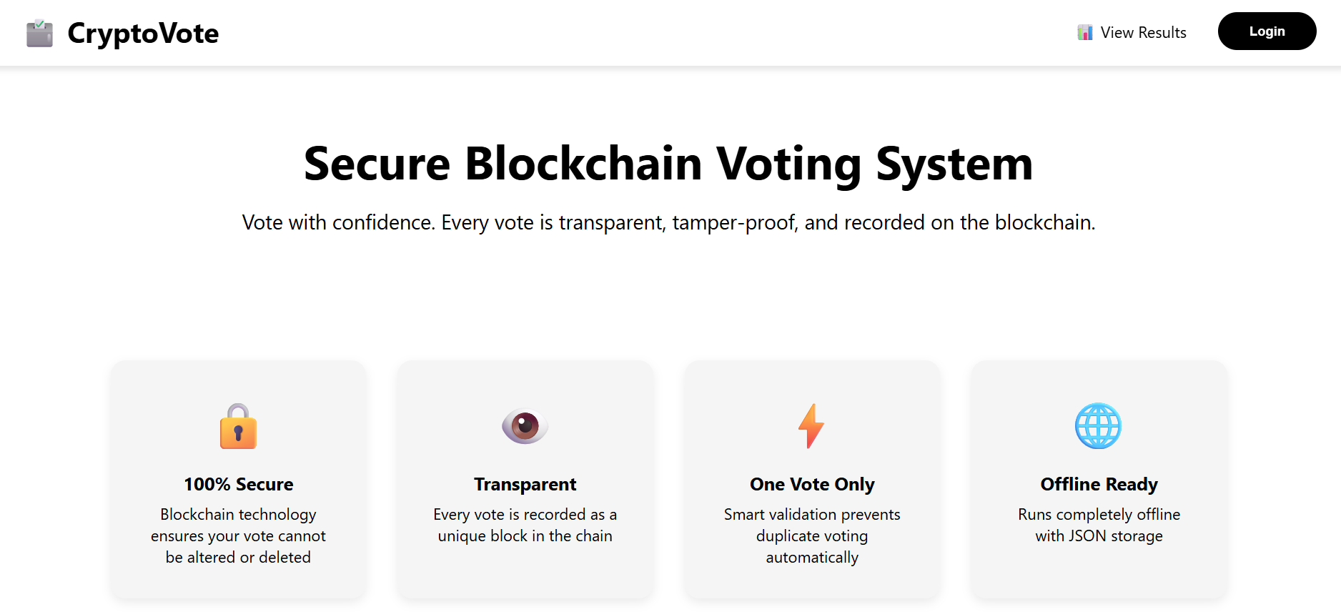

FIGURE NO. A.3.1 User Interface

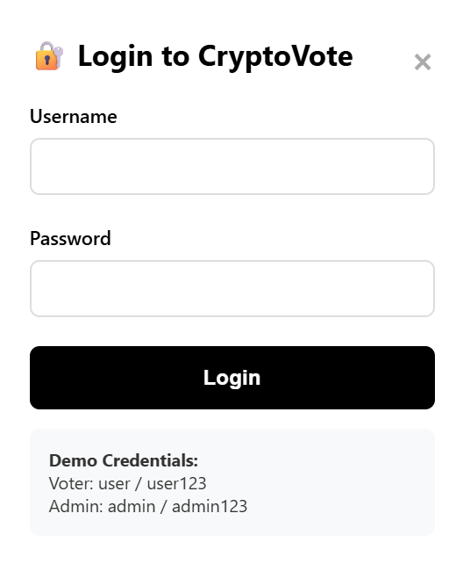

FIGURE NO. A.3.2 User Authentication Interface



FIGURE NO. A.3.3 User Dashboard Interface

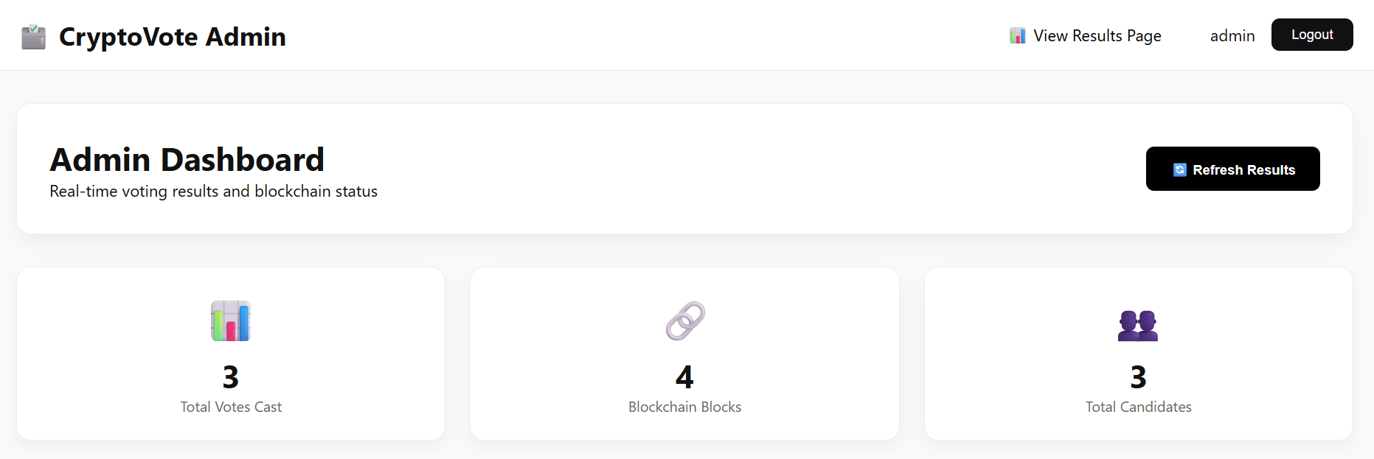

FIGURE NO. A.3.4 Admin Dashboard Interface



FIGURE NO. A.3.5 Live Voting Results

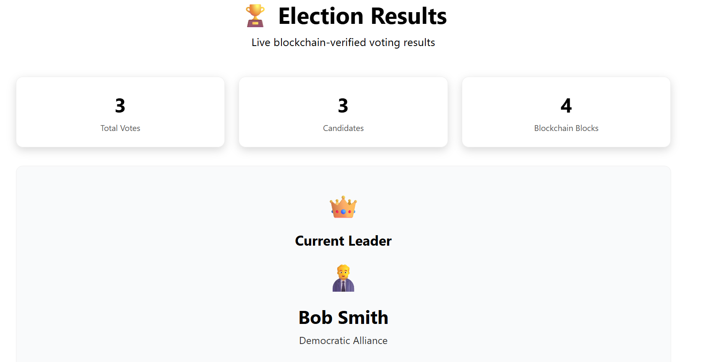

FIGURE NO. A.3.6 Election Results Interface

REFERENCES

    - A. Shaikh, B. Kumar, R. Mehta, “Blockchain-Enhanced Electoral Integrity,” IEEE International Conference on Secure Digital Governance, Volume No: 4, 2025.
    - A. Sharma, P. Verma, S. Roy, “Blockchain-Based E-Voting,” IEEE International Conference on Smart Digital Systems, Volume No: 2, 2022.
    - B.Jayakumari “E-Voting System Using Cloud-Based Hybrid Blockchain,” IEEE International Conference on Cloud and Cyber Security, Volume No: 3, 2024.
    - D.S. Rafianti, M. Fadli, R. Ahmad, “Blockchain-Based E-Voting System: Bibliometric Analysis,” IEEE International Conference on Digital Innovation Trends, Volume No: 2, 2024.
    - R. Patel, N. Gupta, “Electoral Integrity with Blockchain,” IEEE International Conference on Secure Governance Technologies, Volume No: 4, 2025.
    - R. Ramyadevi, S. Mohan, L. Prakash, “Blockchain-Powered E-Voting System,” IEEE Int. Conf. on Next-Generation Computing, 2024.
    - R. P. Tejushree, V. Nair, S. Kumar, “Secure E-Voting: Leveraging Blockchain Technology,” IEEE International Conference on Distributed Digital Security, Volume No: 3, 2024.
    - S. Gnanapriya, “Secured Electronic Voting System Using Blockchain,” IEEE Int. Conf. on Information Security Applications, 2023.
    - S. H. Shakir, M. Rahman, T. Ahmed, “A Blockchain-Based E-Voting System for Fast and Secure Elections,” IEEE International Conference on Emerging Computing Technologies, Volume No: 5, 2024.
    - U. Jafar, M. Ali, “Blockchain for Electronic Voting Systems,” IEEE International Conference on Advanced Cyber Technologies, Volume No: 1, 2021.

PUBLICATION / CONFERENCE

1. Mrs.K.Gandhimathi, Dhanush K, Giridharan P, Gokulnath K, “CryptoVote: Blockchain Inspired E-Voting System”, National Conference on Innovations in AI, Machine Learning and Cybernetics (NCAIMLC), organized by the Department of Artificial Intelligence and Machine Learning and Computer Science and Business Systems at Bannari Amman Institute of Technology, Erode, Tamil Nadu on January 24, 2026.

